Sales and Inventory Database Management System
Prepared for: A and P Pharmacy
Prepared by: Nico le John Mortel
IToolbox ™
John Paul Francisco

Release Date: January 17, 2021
Version number: 2.1.1

Version History
IToolbox ™

Version 1.0 ……………………………………………………………...November 29, 2020
Release Notes: includes the following functionalities:
+ Login of user
+ Add/View/Update of products and inventory
+ Manage Employee Transaction who update the database
+ Generate report of the inventory
Version 2.0……………………………………………………………...December 19, 2020
Release Notes: revised and additional features:
+ Revise UI design and include logo
+ Add the stocks monitoring and sales
Version 2.1……………………………………………………………...December , 2020
Release Notes: revise and simplify process and transaction of the system:
+ Revise COMPANY NAME Menu / Details – make a separate form showing details about the
company.

+ Remove CUSTOMER, SALES MAN, EMPLOYEE, CATEGORY, SUB-CATEGORY, and PURCHASE Menus.

+ Under PRODUCT STOCK MENU, remove QTY only total stocks remaining. Add expiration status (Good, Near Expiry, Expired).

+ Under PRODUCT ENTRY, rename/remove and simplify Category/Sub-category of Products (UOM – Unit of Measurements drop-down only) . Include supplier details as well.

+ Under SALES ENTRY, disable edit in Product ID, Product Name, and Amount. Remove Discount, GST, Total Amount, Customer Name, Sales Man ID, and Sales Man Name. Rename ‘Due’ to ‘Change’.

+ In Reports, retain STOCKS (Product Stocks) and SUPPLIER (list of suppliers) ONLY.

+ Fix bug in registration (remove user name, retain user id only).

EXECUTIVE SUMMARY

Overview
This user acceptance document is to accept the functionality of the requirements for P & A Pharmacy Inventory with Database Management System which includes the following features:
- Login of user
- Viewing/Adding/Updating of sales products and inventory in database
- Monitor Stocks and Sales.
- Generate report of the Stocks and Suppliers.

Objective
To be able to create database management system for Pharmacy Inventory.

Goals
To have an inventory of pharmacy’s products and services.

Solution
Based on the understanding of Pharmacy requirements, IToolbox developed a database management system for Pharmacy that will have an inventory of their products in stand-alone system.

Project Outline
IToolbox ™

User Interface / User Manual :
As the database application started, login page will appear. User should select username listed (admin created accounts).


Upon selecting username, user must input password, then PRESS ENTER to login. After user successfully login, user will see the main page:
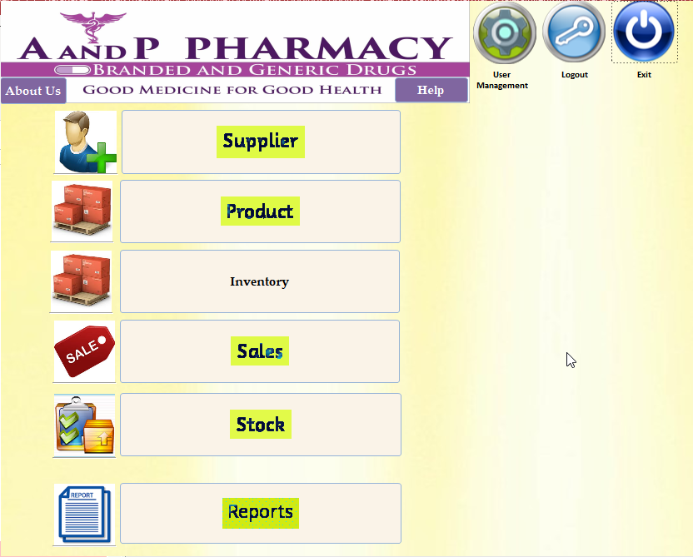

About Us Page:
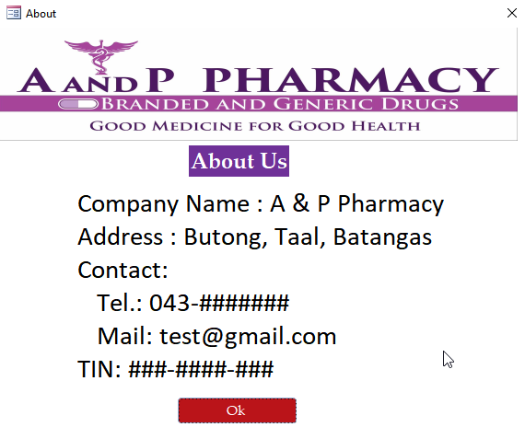
Help Page:
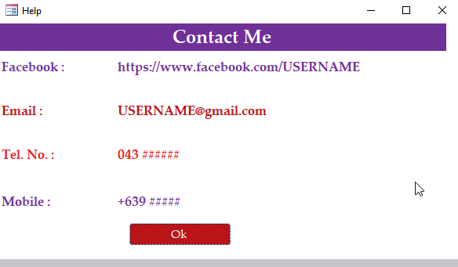
Supplier Page:Once you click th supplier button, supplier entry will appear and input the new supplier.
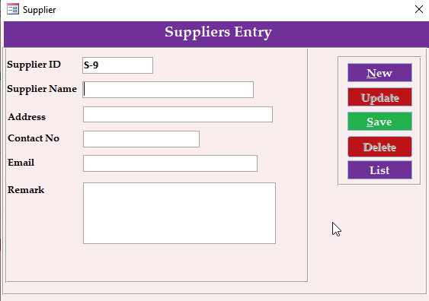
In order to see the list of supplier, user may click the List button:
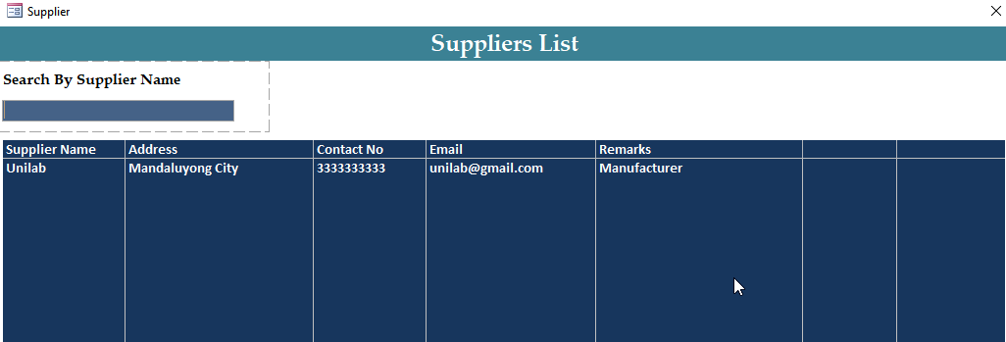
When you click one of the lists, you may update/delete that record by clicking the update and delete button on the right.
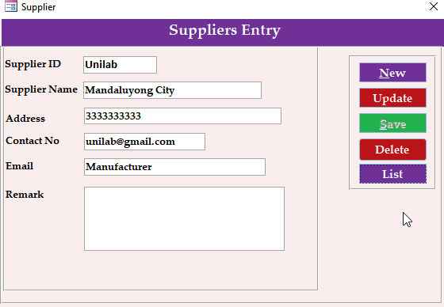

To add new record, click New and then fill the form and then click Save:
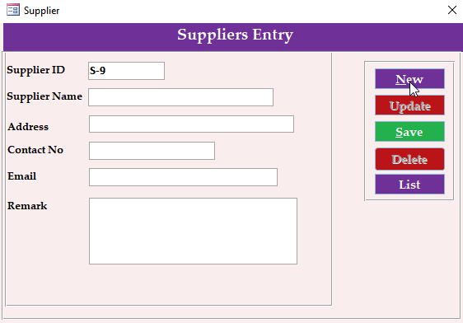

To input product invertory, product must be entered first in product entry menu:
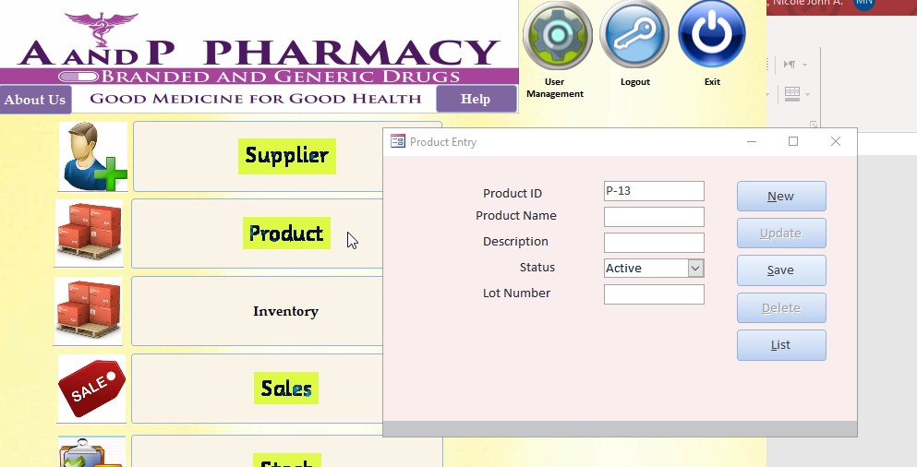
Once product has been entered in the database report we can add information in inventory by selecting from the product list and supplier list as input:
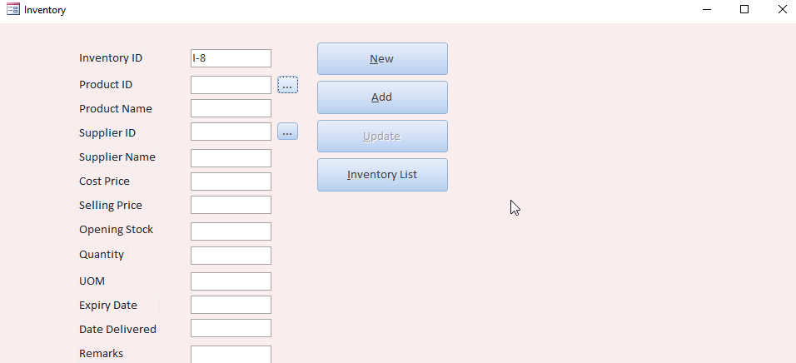

Project Cost
IToolbox ™
This project cost includes database management features of pharmacy inventory.

Key Stakeholders
Client | Aileen Paradero
System QA | John Paul Francisco
Systen Developer | Nicole John Mortel

Evaluation / Feedback

Approval Signatures

Aileen Paradero  Project Client |  | John Paul Francisco  System QA |  | Nicole John A. Mortel  System Developer

